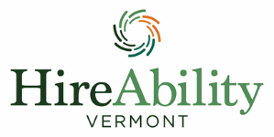

INTERAGENCY CORE TEAM EVENT
October 8. 2024
Killington Grand Hotel

WORKSHOP DESCRIPTIONS AND RESOURCES
Youth Panel: Hear real experiences from youth as they use their voice to advocate for change.
Creating Inclusive Communities for Youth in Transition: Supporting youth with high levels of need to access their communities with Dr. Kendra LaRoche from the Special Needs Support Center.
Recommendations Exemplar
Preparing Businesses to Hire People With Disabilities
Enabled Upper Valley
Disability-Friendly Pledge
Panel of Professionals: Hear from a panel of educators and other youth professionals about raising the bar for youth in everyday practice.
Mental Health Literacy for Transition Aged Youth: Speaker Sunny Naughton. What is mental health literacy for transition aged youth. What is important to know for both youth and their support teams when it comes to this topic.
Mental Health Literacy
Vermont Mental Health Literacy Resources
The Role of the Business Account Manager: Overview of what a business account manager does, reframing what we know about youth to employers, and labor market information. Speakers: Nat Piper and Katie Coe from HireAbility Vermont.
Removing Barriers to Dual Enrollment: Supports and services to support youth with disabilities to access Early College and Dual Enrollment/Fast Forward. (Representatives from HireAbility, College Compass, CCV

