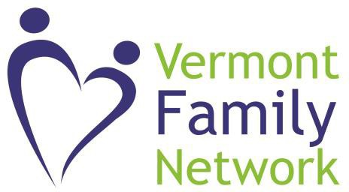 

Vermont Family Network’s Family Support Fund

Vermont Family Network receives a grant from the Vermont Department of Health’s Children with Special Health Needs program to assist families with out-of-pocket medical expenses and their unmet respite needs. When applying, we will offer support and resources to help navigate medical and healthcare financing systems. This is a fund of last resort.

**Eligibility**

* Vermont residents aged 0 through their 21st birthday
* Have a chronic physical, medical, or developmental condition
* Requires health and related services of a type or amount beyond that required by children generally
* Household income at or below 500% of the Federal Poverty Level

**Medically Necessary Supplement Funds** are for items or services that are not otherwise covered by insurance (or other funding) and are considered medically necessary as documented by a physician with knowledge of the child. Past requests have included: medical equipment and supplies, therapies, medical travel, provider bills, deductibles, prescriptions, and more. Applications are completed through a phone interview with a parent. Families may access up to $1500.00 per grant year. [Info@vtfn.org](mailto:Info@vtfn.org) or call 802-876-5315.

**Respite Funds** are available to primary caregivers who do not have any other respite or flexible family funds available to them. We define respite as a planned break for the caregiver. The parent self-identifies their respite need and develops a plan to utilize funds that will help them achieve their respite goals. Typically, [info@vtfn.org](mailto:info@vtfn.org) -876-5315.

Completed applications are reviewed weekly by a team of VFN and CSHN staff. Applicants will be notified of the review team’s decision within a few days.

Families may apply for one or both aspects of the fund for a combined total of up to $1500 per fiscal year. For all requests over $600.00, VFN will need to have a W-9 Form on file.

The Family Support Fund does not pay for vehicles, housing, therapies that are not evidence-based, or non-prescribed medications or supplements. For families without Medicaid, the fund may be able to assist with Hearing Aids, Medical Travel, and/or Communication devices.